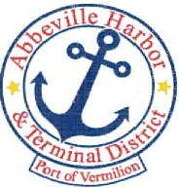

P.O. Box 1410, Abbeville, Louisiana • 70511-1410  
 Ph: 337-893-9465 Fax:337-898-0751 www.abbevilleharbor.com

ABBEVILLE HARBOR & TERMINAL DISTRICT

OCTOBER 29, 2024

5:00 P.M.

**NOTICE OF PUBLIC HEARING**

1. CALL MEETING TO ORDER – PRESIDENT JIMMIE STEEN

A. ROLL CALL

B. WELCOME & INTRODUCTION OF GUESTS

2. PUBLIC COMMENT ON 2025 PROPOSED BUDGET

1. 2025 PROPOSED BUDGET
2. ADJOURN

Jimmie Steen, President Tim Creswell, Commissioner

Patrick Duhon, Vice President Wayne LeBleu, Commissioner

Carlton Campbell, Secretary-Treasurer Nicholas Gautreaux, Executive Director Bud Zaunbrecher Commissioner